**Test Network Project**

Efrem Sendek

Metropolitan Community College

INFO 2810: Cybersecurity Capstone

Gary Sparks

October 15, 2023

This project is about creating a safe computer network that protects against cyber threats. It involves setting up a network with different types of computers in the vSphere. The main aim is to find and fix any weaknesses in the network to make it secure.

**Network Building and Initial Configurations:**

In the initial stages of this cybersecurity initiative, a robust network was meticulously crafted to serve as the foundation for subsequent testing and mitigation efforts. The network consisted of four distinct virtual machines, each one bearing the student’s name as part of its unique identifier:

1. Windows Server (esendek_Windows Server)
2. Linux Server (esendek_Linux Server)
3. Linux Client (esendek_Linux Client)
4. Windows Client (esendek_Windows Client)

These machines were installed following industry standards and best practices. Windows Server and Windows Client were equipped with the least Microsoft operating systems, while Linux Server and Linux Client ran on widely used distributions like Ubuntu and CentOS. The configuration process included setting appropriate resources, network settings, and security configurations to ensure a secure and functional network environment.

**A. Installing Windows Server**

In this project, I used vSphere to create a virtual machine (VM) for Windows Server. I installed Windows Server by booting from the ISO file, following the prompts for language, license, and disk selection. After installation, we configured network settings for communication.

**B. Installing Linux Server**

I initiated the installation process by booting the VM from a Linux distribution ISO file. Following the on-screen prompts, I selected language preferences, accepted the license agreement, and specified disk partitions. After the installation was completed, I configured network settings to enable communication with other devices.

**C. Installing Linux Client**

The setup process involved booting the VM from a Linux distribution ISO file. I then followed on-screen instructions to select language preferences, accept the license agreement, and allocate disk space. Once installation was complete, I configured network settings to enable connectivity with other devices on the network.

**D. Installing Windows Client**

Beginning with vSphere, we initiated the VM setup by booting from a Windows installation ISO file. Following the prompts, we selected language options, agreed to the license terms, and designated disk partitions. After installation, we configured network settings to facilitate communication with other devices on the network.

Windows Server Installation in The VM environment.

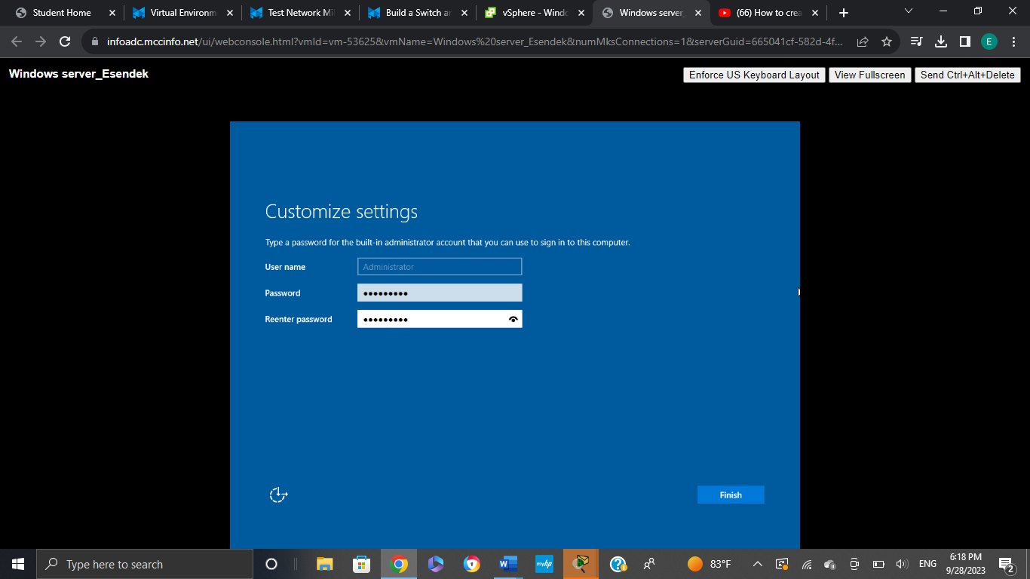

Linux Server Installation in The VM environment.

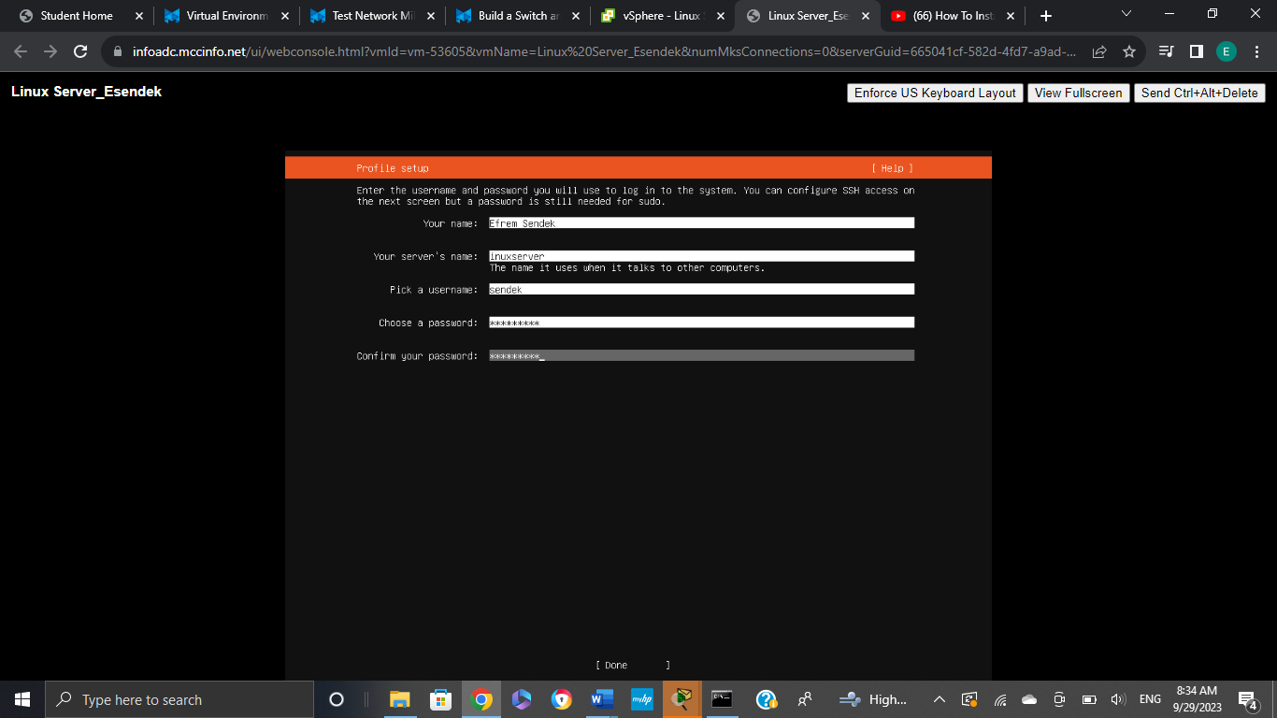

Windows Client Installation in the VM

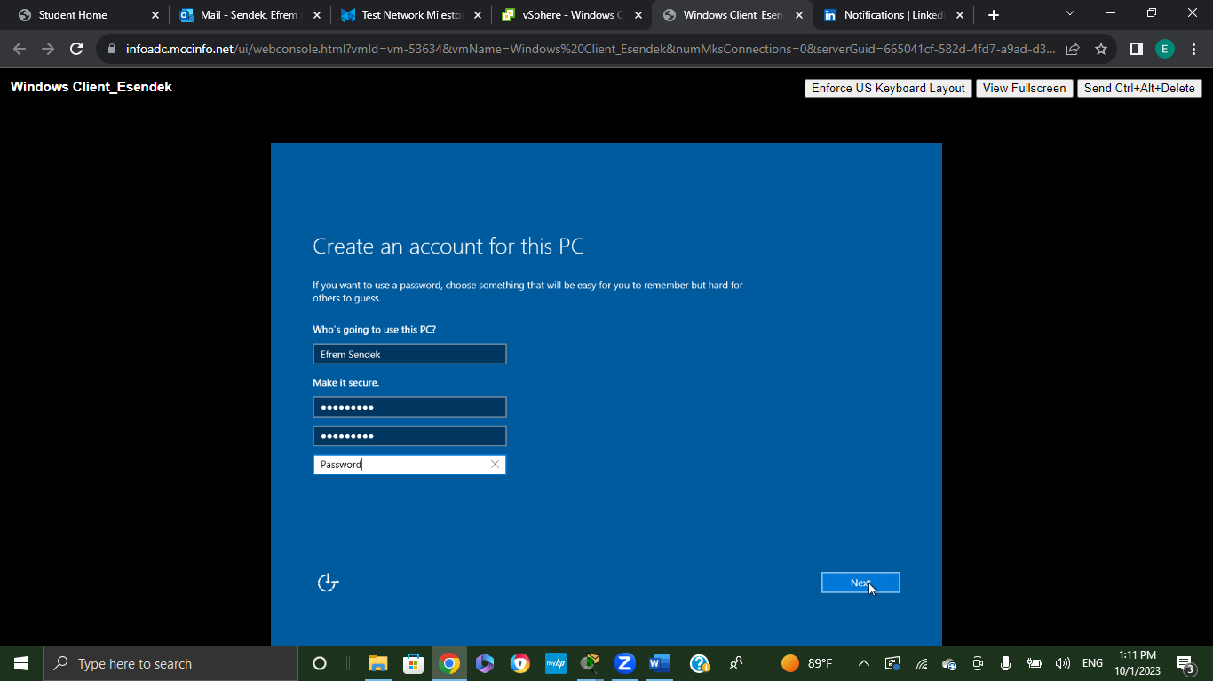

Linux Client Installation in the VM

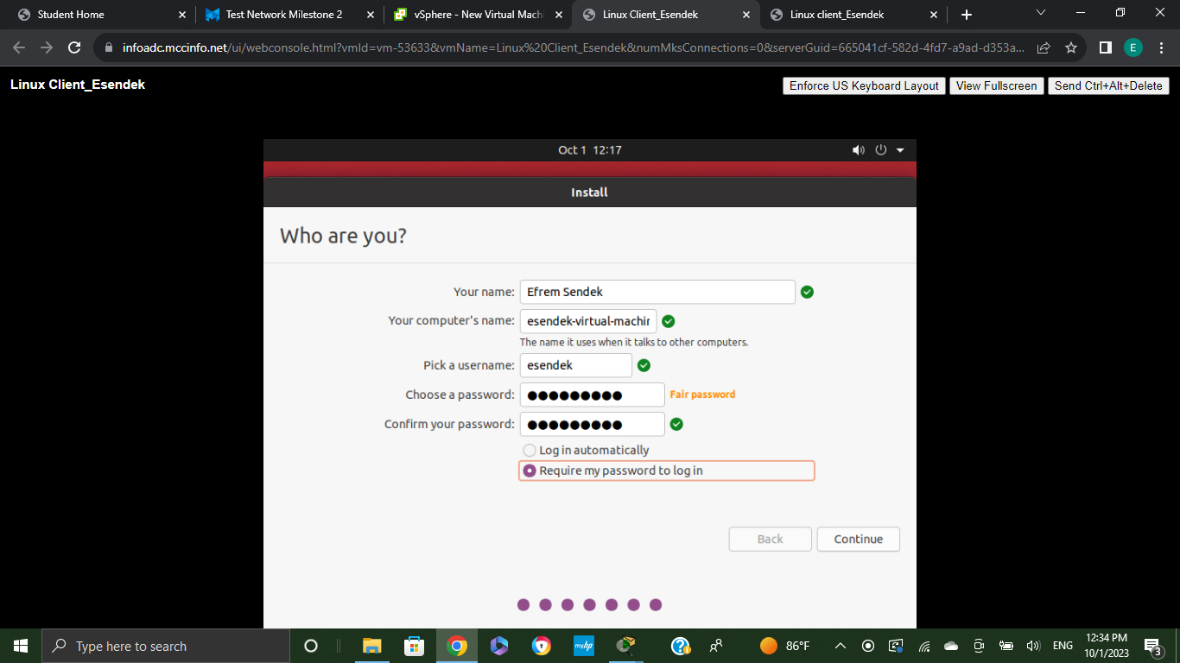

Installation of Nmap in Linux Client 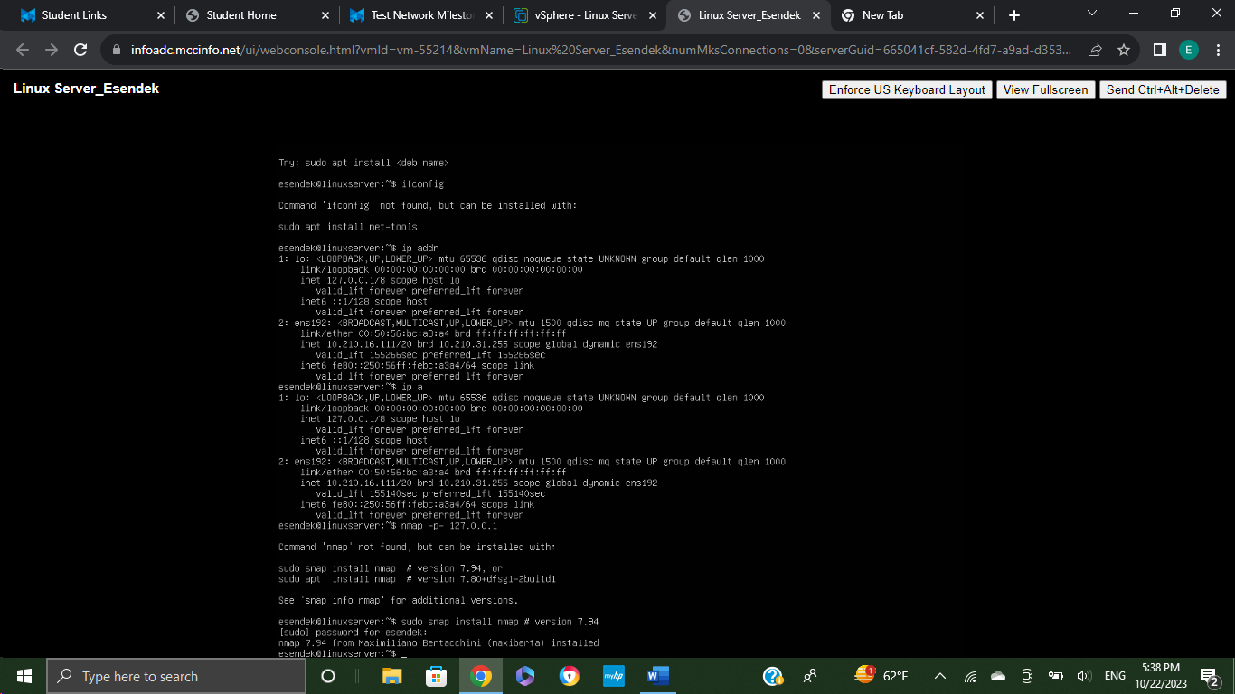

Net-tools need to be installed to be able to use Linux Client (Ubuntu) properly. This is the command used sudo apt-get install net-tools 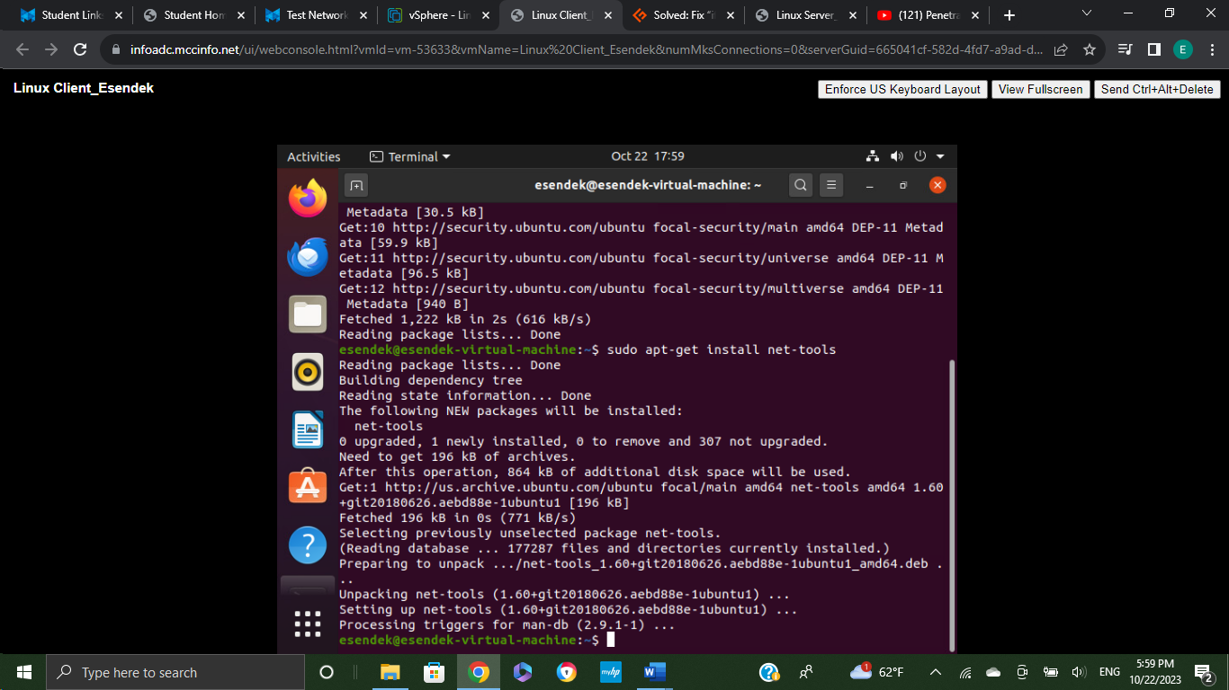

Installation of Nmap 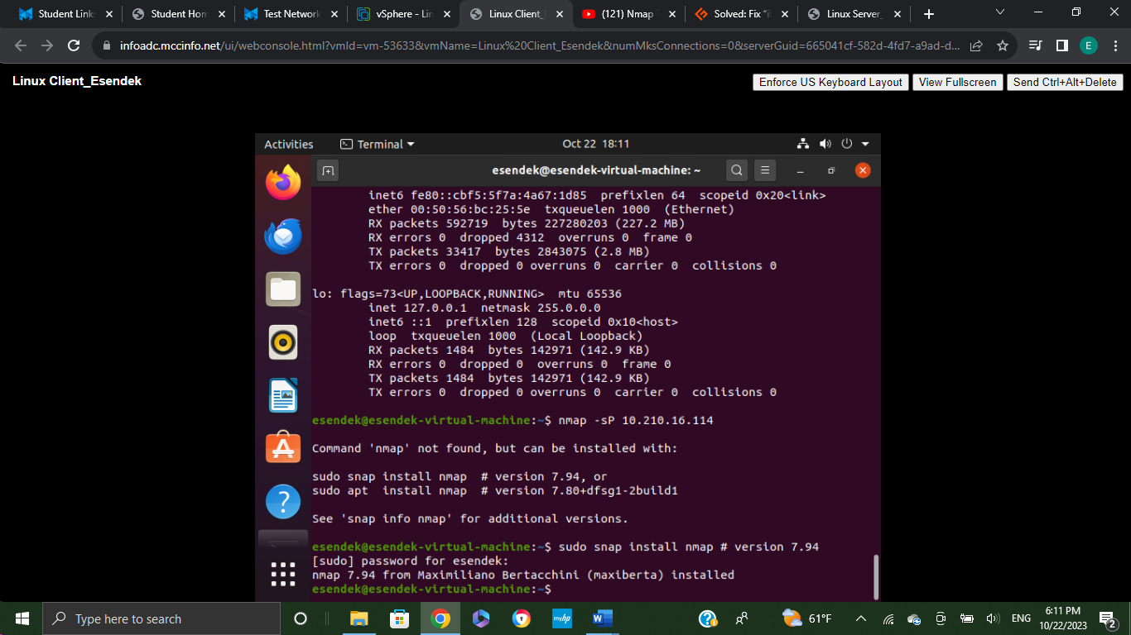

In 4.46 seconds 56 hosts were up 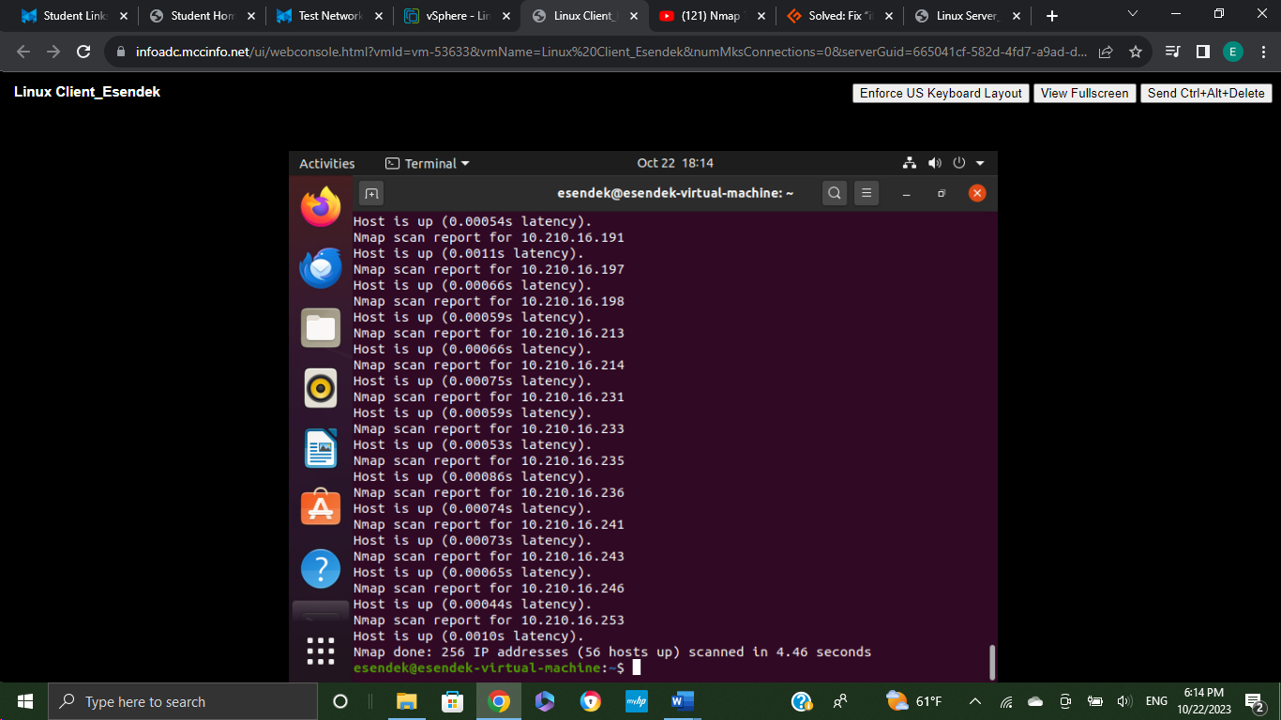

In this milestone, vulnerability testing was conducted on the computers built in the previous assignment. The objective was to identify and assess potential vulnerabilities that could compromise the security of the systems. All work was performed within the virtual machine (VM) environment, and relevant captures include the VM name for documentation purposes

**Tools Used:**

1. Nmap: installed via the command sudo apt-get install nmap for comprehensive network scanning. It conducts network reconnaissance to discover open ports, services, and potential vulnerabilities in target systems.
2. Wireshark: is employed for packet analysis and network traffic monitoring. It captures and analyzes network packets to detect any abnormal or suspicious activities.
3. Nikto: is a web server scanner that performs comprehensive tests against web servers for multiple items, including dangerous files, outdated server software and other potential vulnerabilities. It typically used for server security assessments to identify and address potential vulnerabilities.
4. Aircrack-ng: Aircrack-ng is used for wireless network assessment, including the identification of vulnerabilities in WI-FI security. It assesses the security of wireless networks by analyzing encryption protocols and attempting to crack WI-FI passwords.

The testing revealed a spectrum of vulnerabilities, from outdated software versions to potential weak points in password configurations. These Vulnerabilities were documented comprehensively to lay the groundwork for the subsequent mitigation steps.

**Scanning Details**

* Windows Client (10.210.16.108): one host up, scanned in 41.62 seconds.
* Windows Server (10.210.16.164): one host up, scanned in 21.22 seconds.
* Linux Server (127.0.0.1): One host up, scanned in 0.09 seconds
* Linux Client (10.210.16.11) One host was up and scanned in 0.13 seconds

**Telnet and Aggressive Scan:**

* Telnet session conducted to connect to another computer far away. It’s like to remote control for computers. one host was up and running took 0.13 seconds to scan it.
* Aggressive scan in 10.210.16.108 revealed in 26.64 seconds and one host was up.

Installing nmap using the command sudo apt-get install nmap

I scanned the Windows Client from the Linux client using the nmap 10.210.16.108 command

In this scan there is one host up and it was scanned within 41.62 seconds.

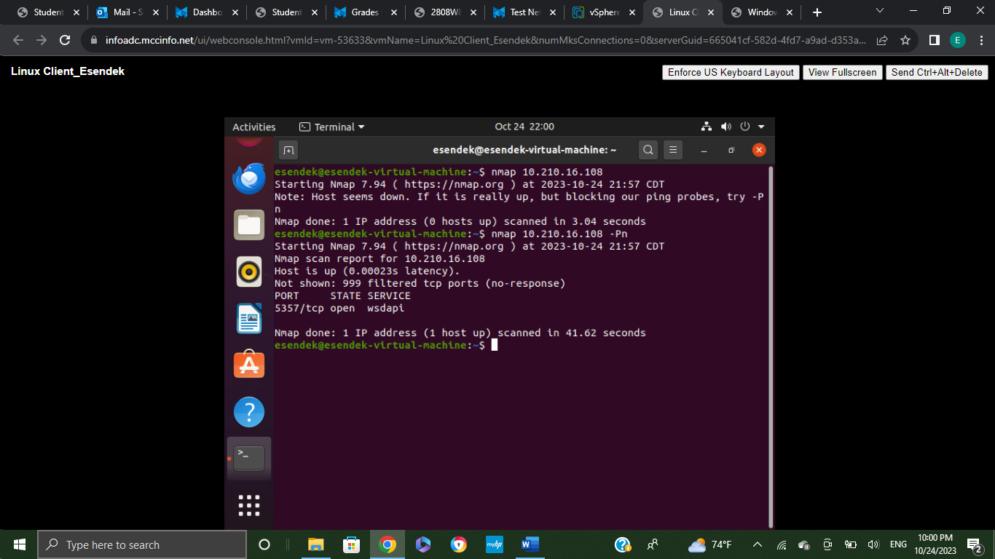

Windows Server scanned from the Linux client using the namp 10.210.16.164 command

One host was up and scanned in 21.22 seconds.

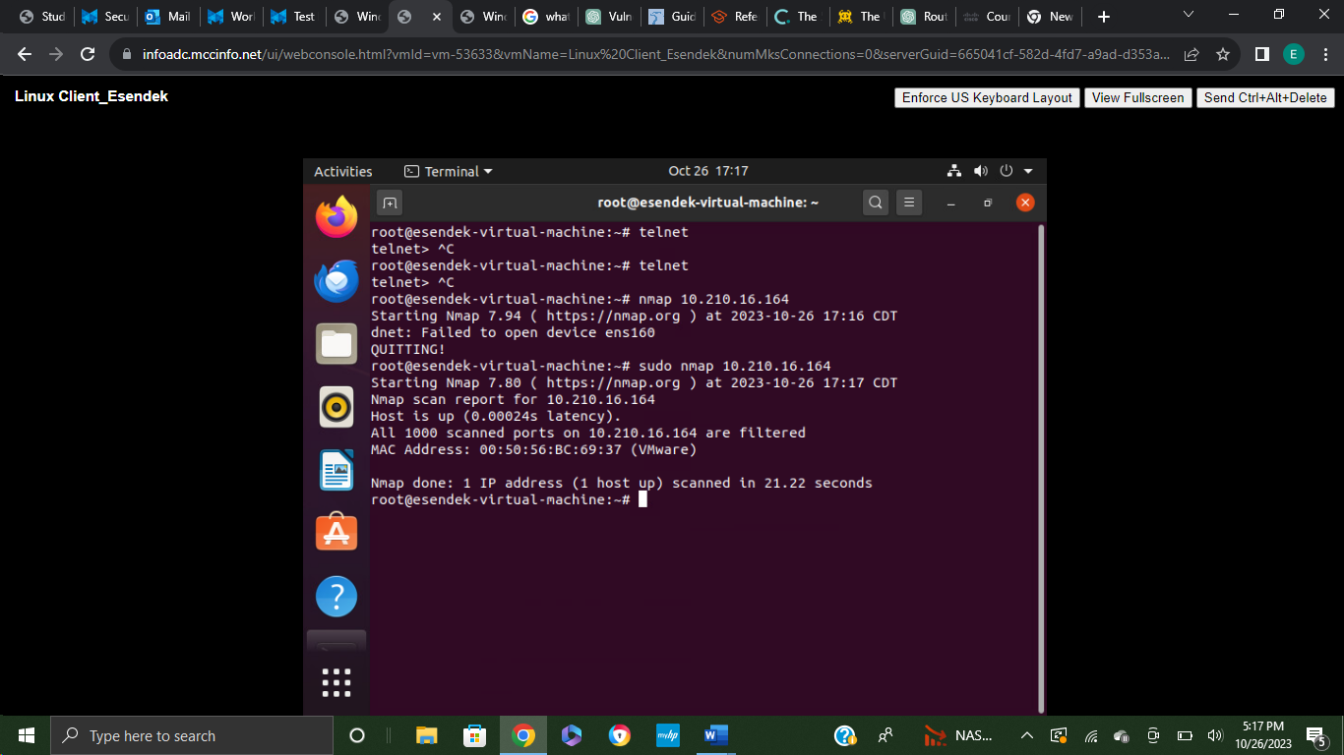

Linux Server scanned from the Linux client using the sudo nmap 127.0.0.1 command.

Ipp were open and it was scanned within 0.09 seconds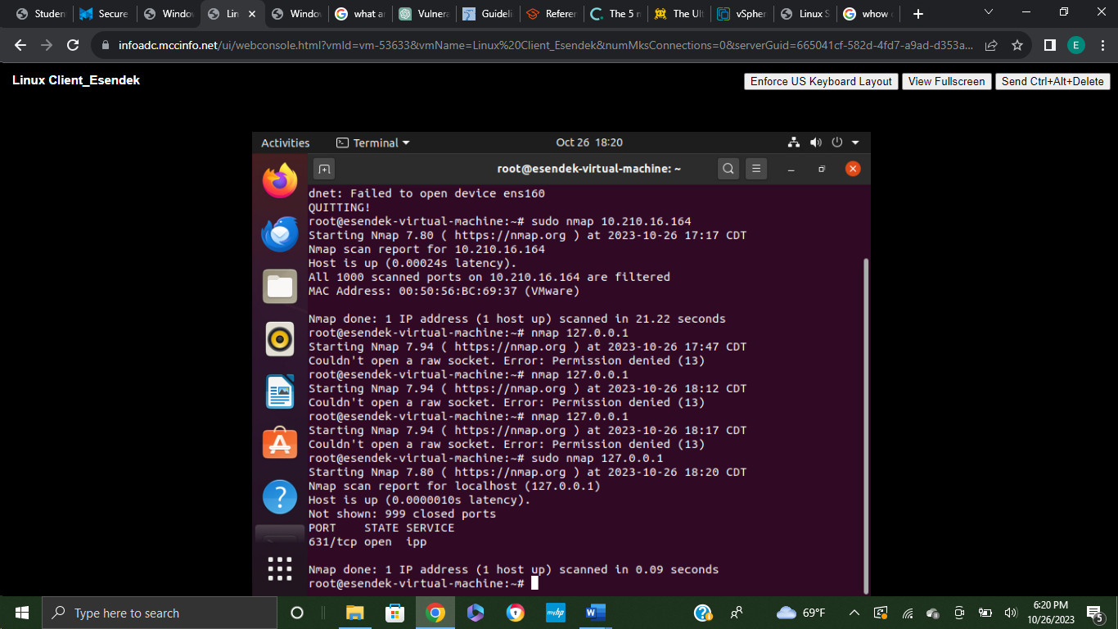

Linux client scanned itself using the command nmap 10.210.16.114

1 host was up and it took 0.13 seconds to scan it and one host was up 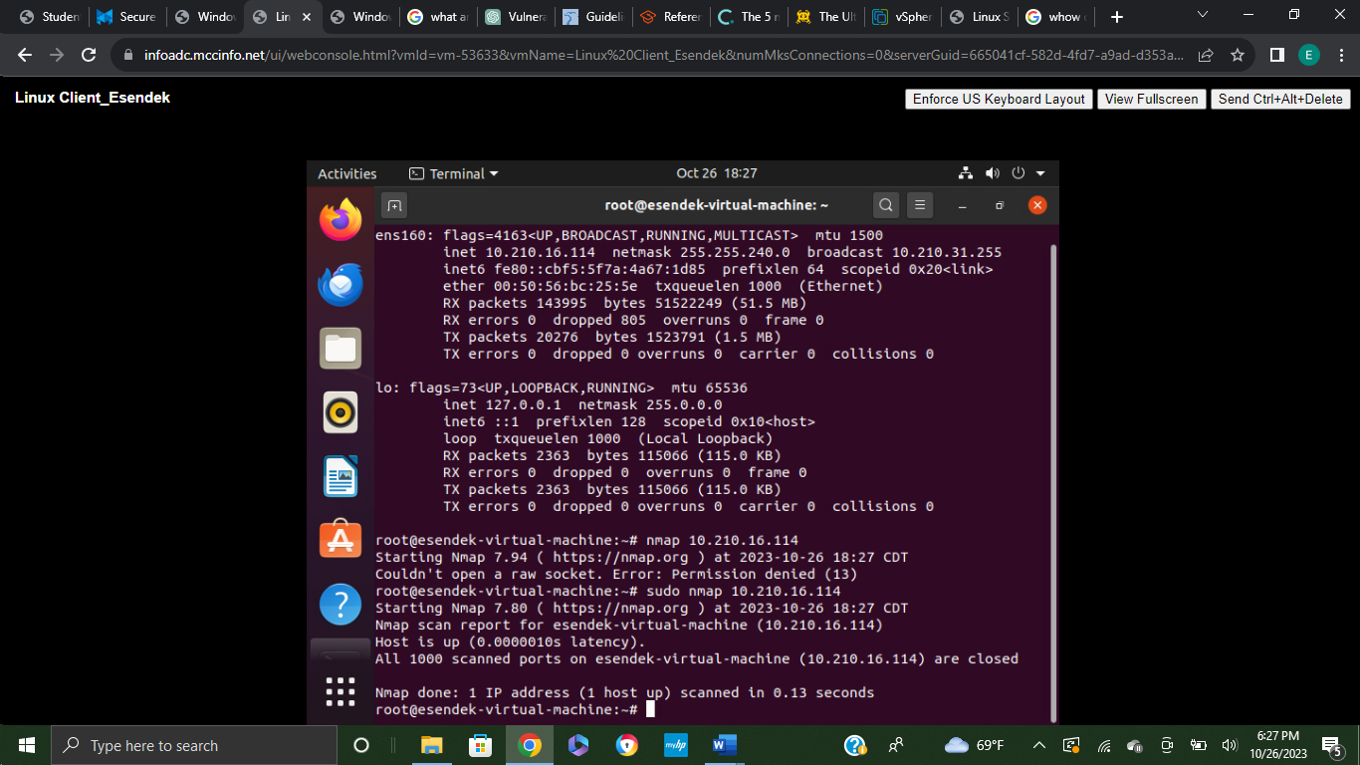

Linux client was scanned using the command telnet, one host was up and running it took 0.13 seconds. 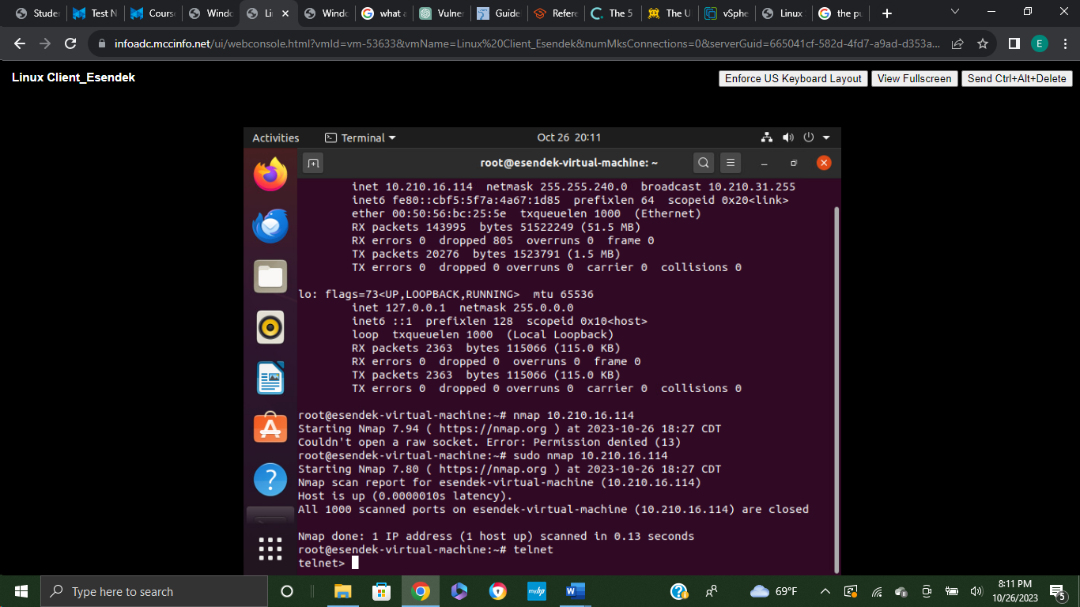

Signing into the root previlege using the sudo su - command 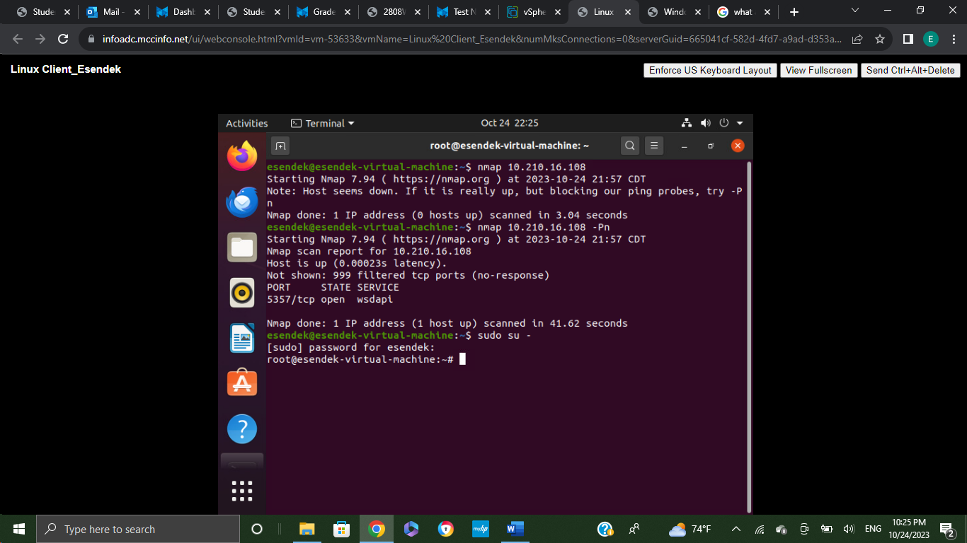

Aggressive scan with OS detection, version detection, script scanning, and traceroute using the command sudo nmap -A 10.210.16.108. 1 host was up and scanned in 26.64 seconds.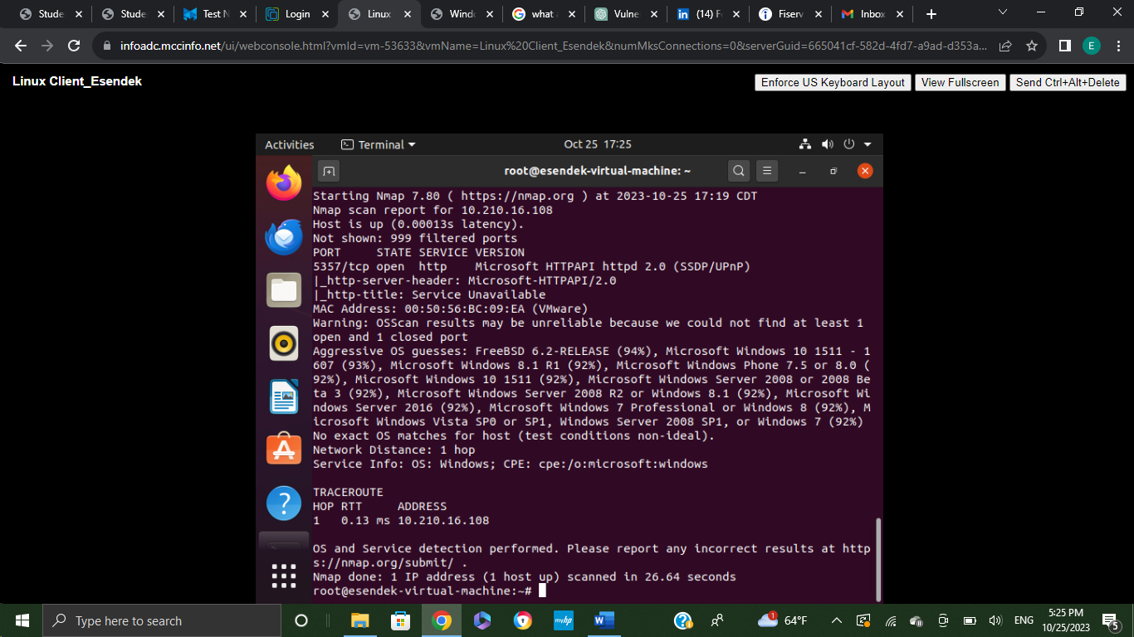

Basic DNS query for a domain was performed using the command dig example.com

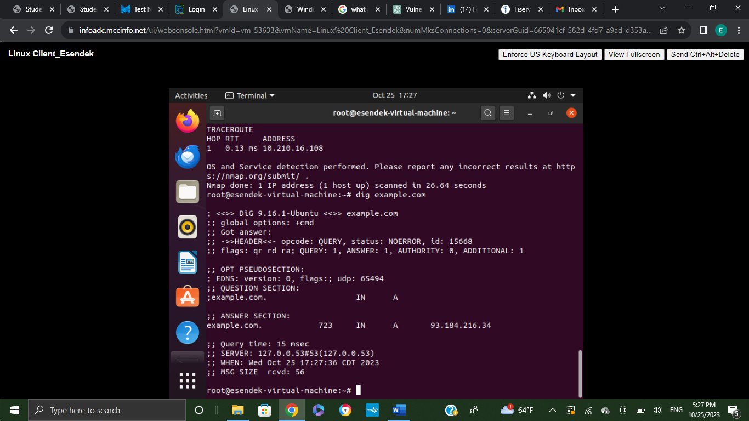

dig -h +nocmd example.com any +multiline +nonquestion command was use to display more detailed information.

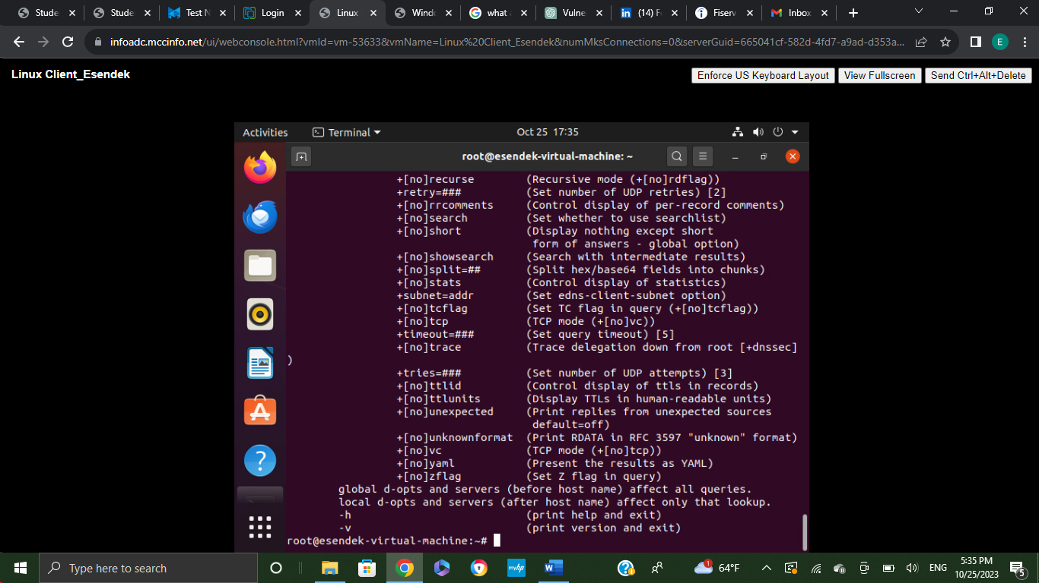

Ping 10.210.16.108 was used to check the network connectivity 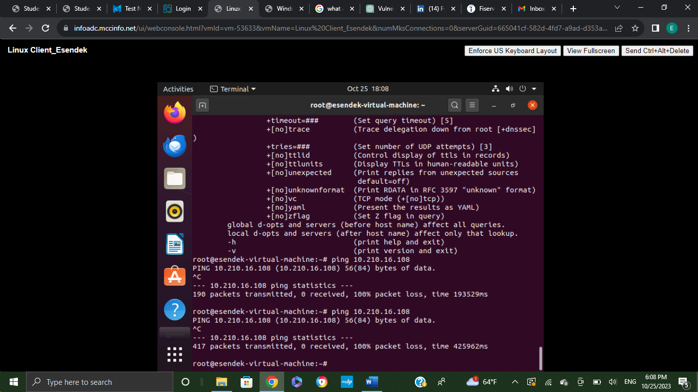

Ping -c 5 10.210.16.108 command was used to send a specific number of packets and 5 packets were transmitted in 4082ms. The machine was blocked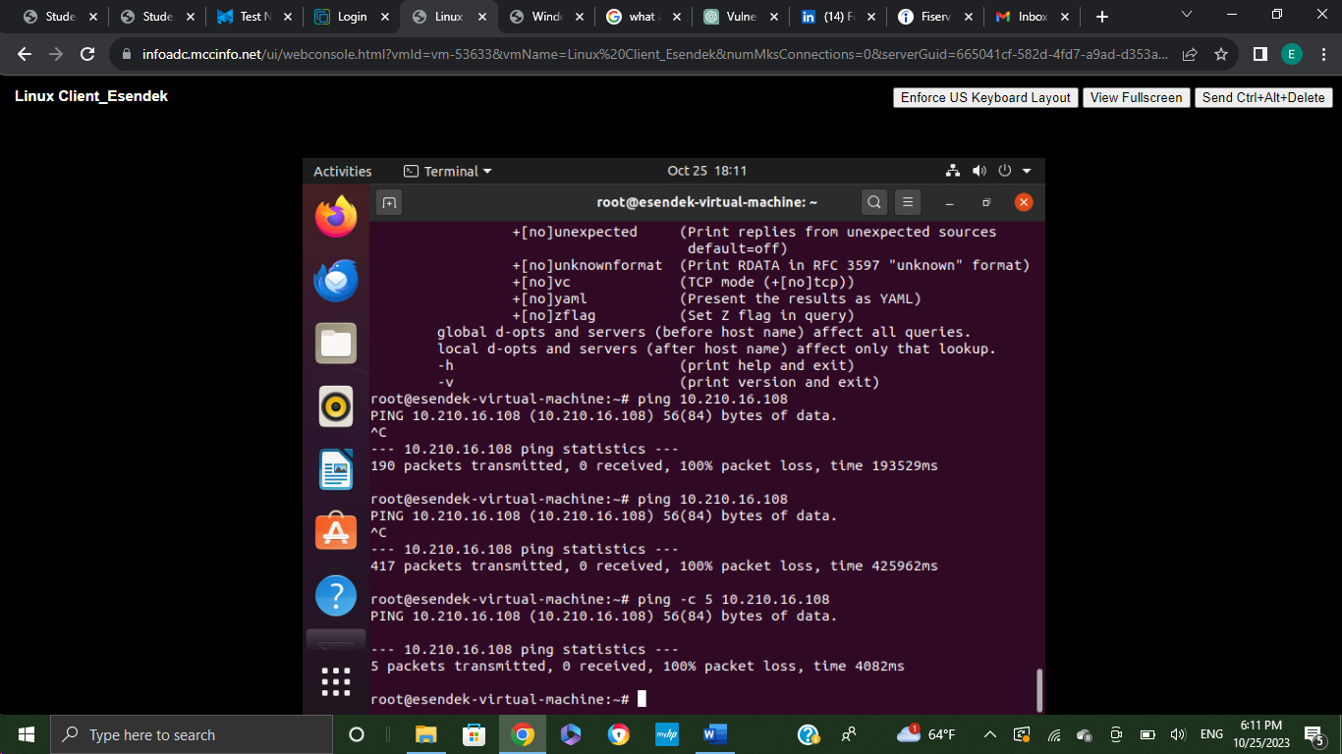

nslookup 10.210.16.114 was used to query an IP address.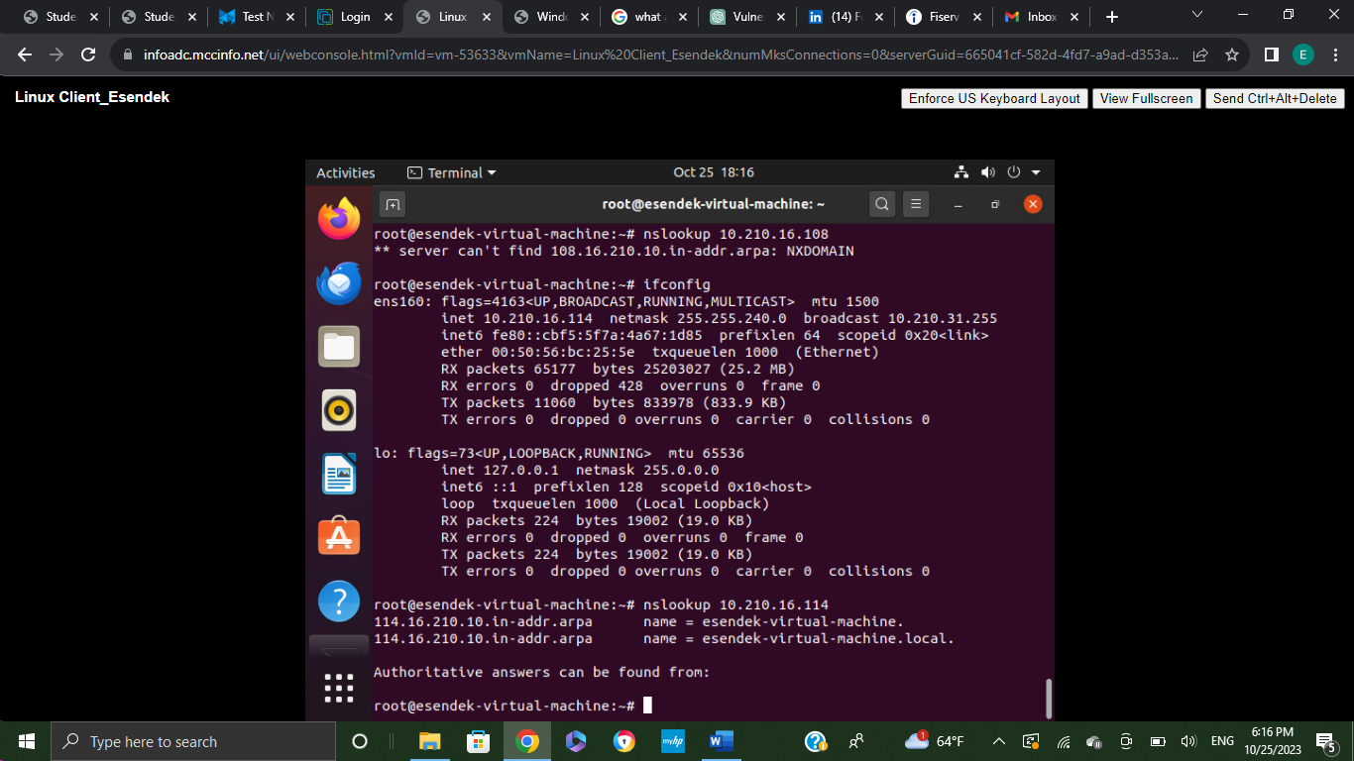

command nslookup -type=PTR 10.210.16.114 was used for the reverse lookup. 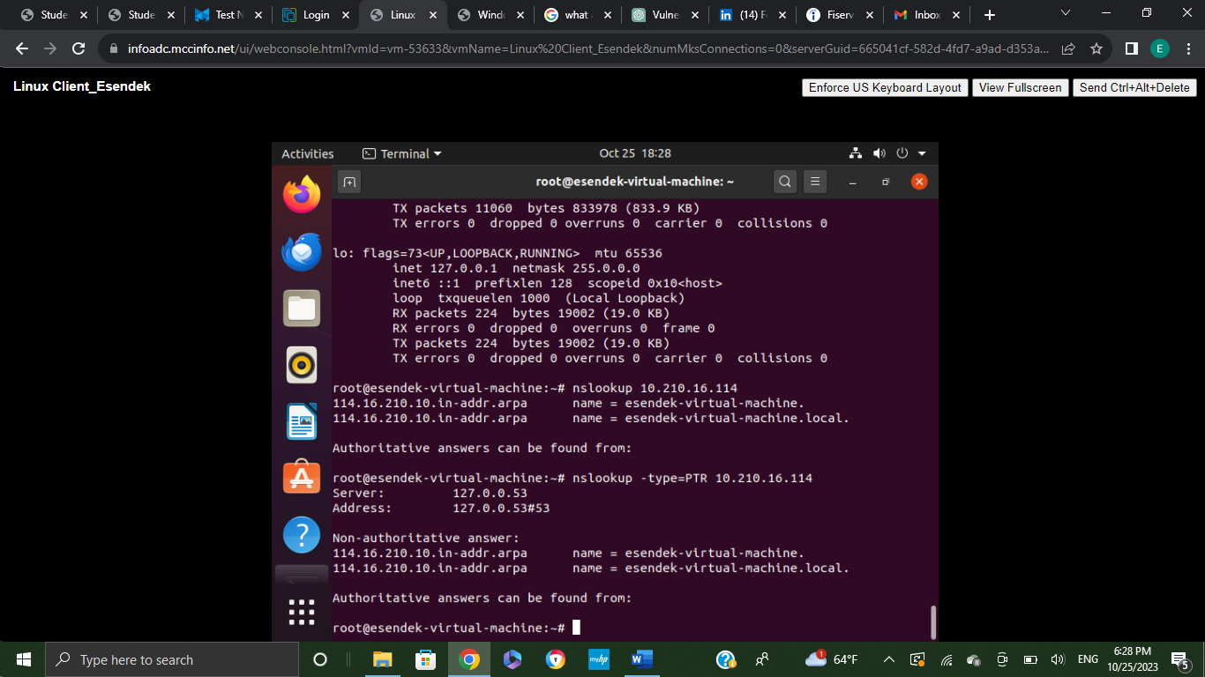

Installation of Wireshark in Windows Client:

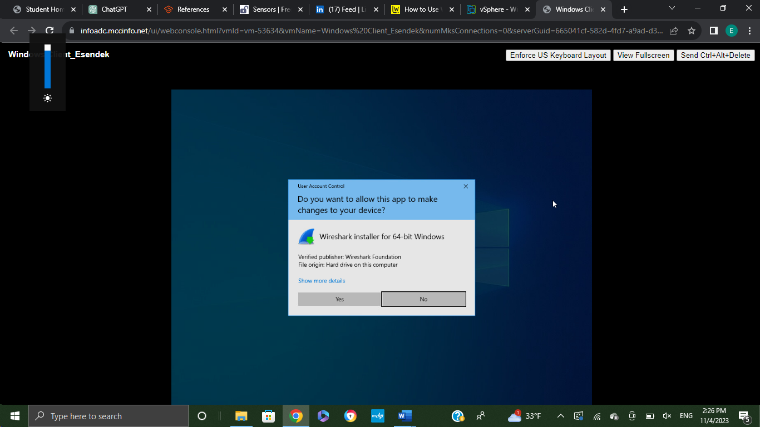

Ethernet 0 was scanned in the capture below. The provided Wireshark screenshot displays network traffic details:

* Packet Listing: Rows represent individual packets, each with source/destination addresses and protocol.
* Protocol Analysis: Identify communication protocols (e.g., TCP, UDP) for insights into network activities.
* Source/Destination Addresses: Shows IP addresses or hostnames of communicating devices.
* Packet Details Pane: Delve into the detailed view for specific packet content and structure.
* Timestamps and Info Column: use timestamps to analyze the timing of network activities, and the “Info” column provides a quick summary.

It also contains three main divisions.

* The packet details list panel (The top section)
* The packet details panel (The middle section)
* The packet bytes panel (The bottom section)

Filters can also be used to identify the capture.

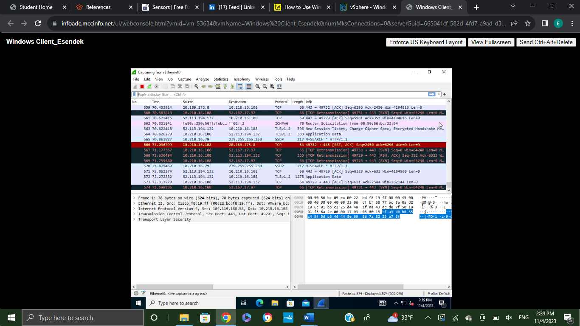

**Nikto**

Screenshots are provided below to show the Installation process of Nikto tool in the Linux Client Virtual Machine. Sudo apt-get install nikto command were used in order to install it. 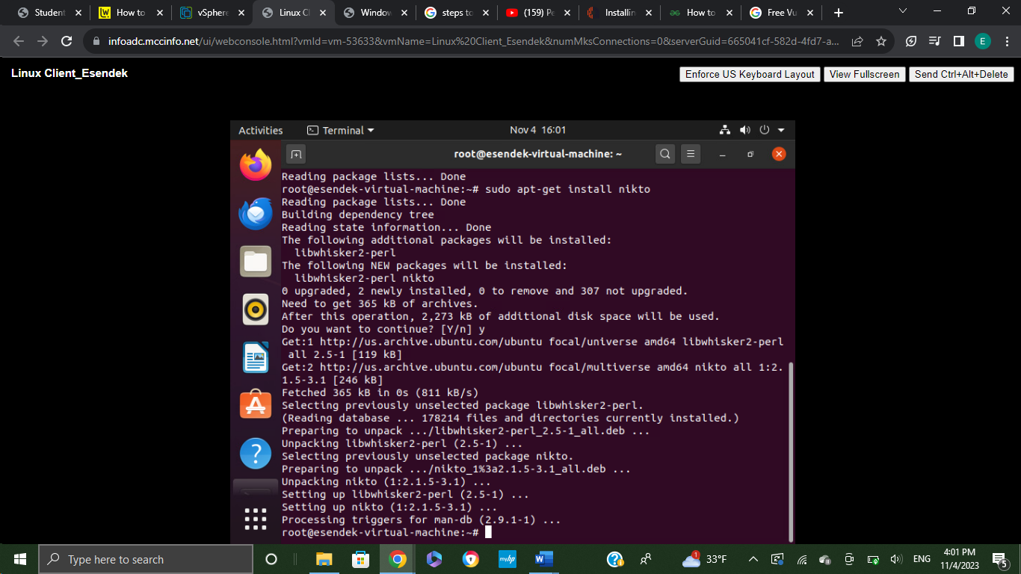

server was scanned by its URL using the command sudo nikto -h <http://example.com> In Linux Client. 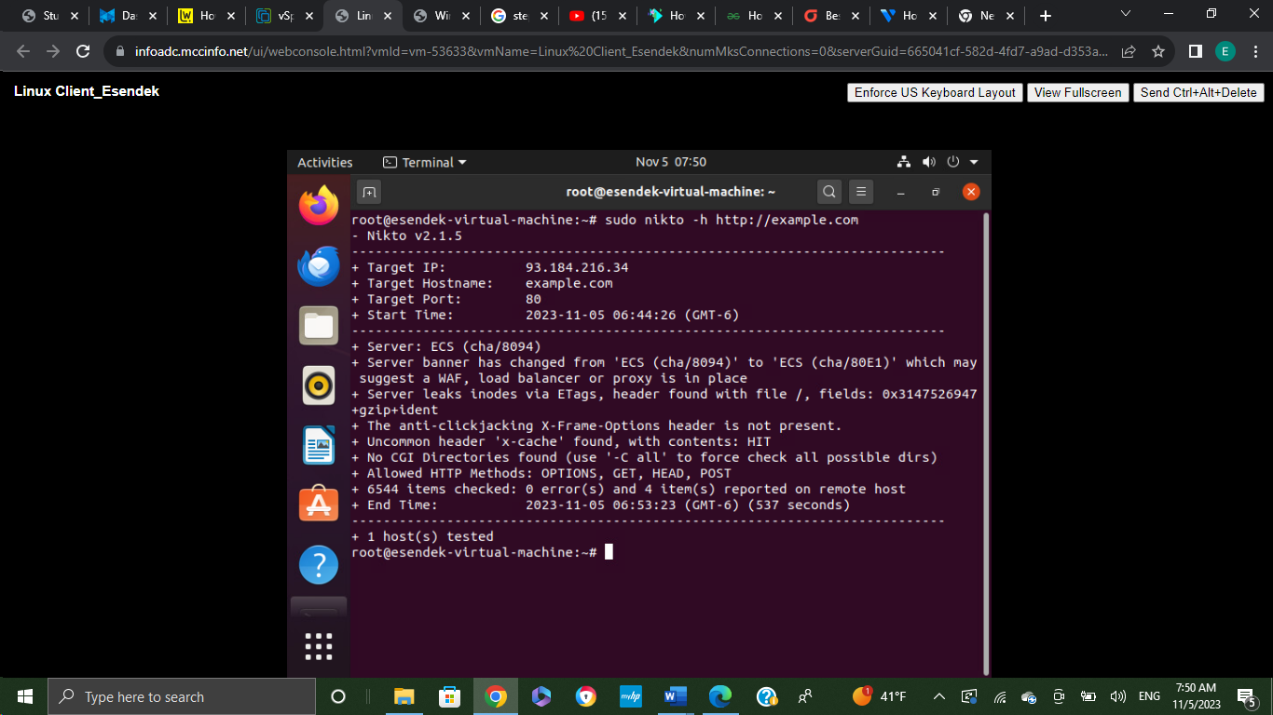

server was scanned by its URL at a specific port using the command sudo nikto -h <http://example.com> -p 8080 In Linux Client.

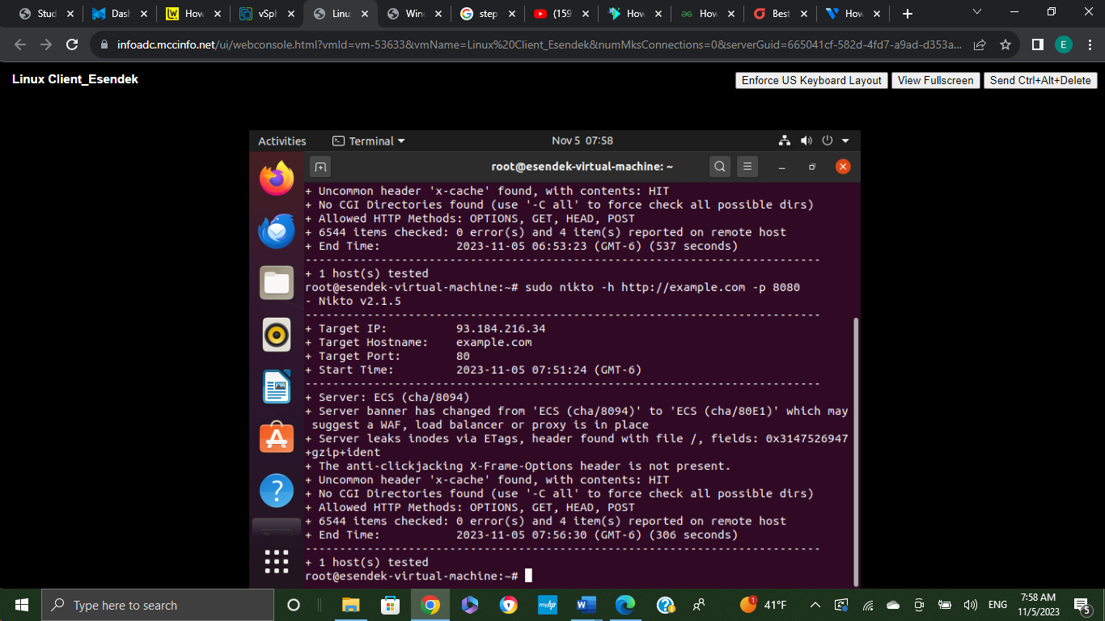

**Aircrack-ng:**

The screenshot provided below shows the Installation of Aircrack-ng in Linux Client using the command sudo apt-get install -y aircrack -ng. 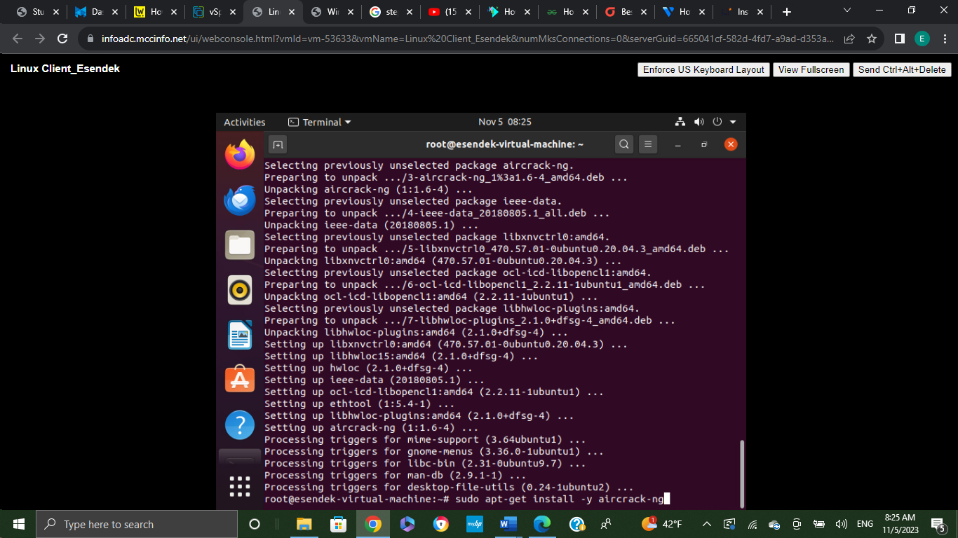

In this case Aircrack-ng was used to crack an encrypted wireless network. First of all listing a wireless cards that is connected to the PC is needed. In order to do that iwconfig command was used. 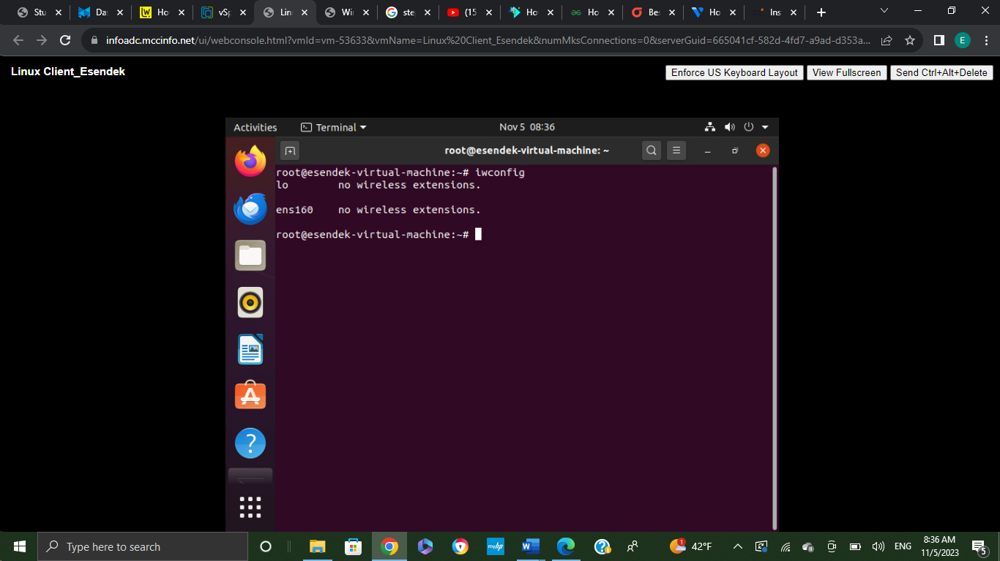

The command sudo airmon-ng check kill was used in order to kill the process that is running on wireless. 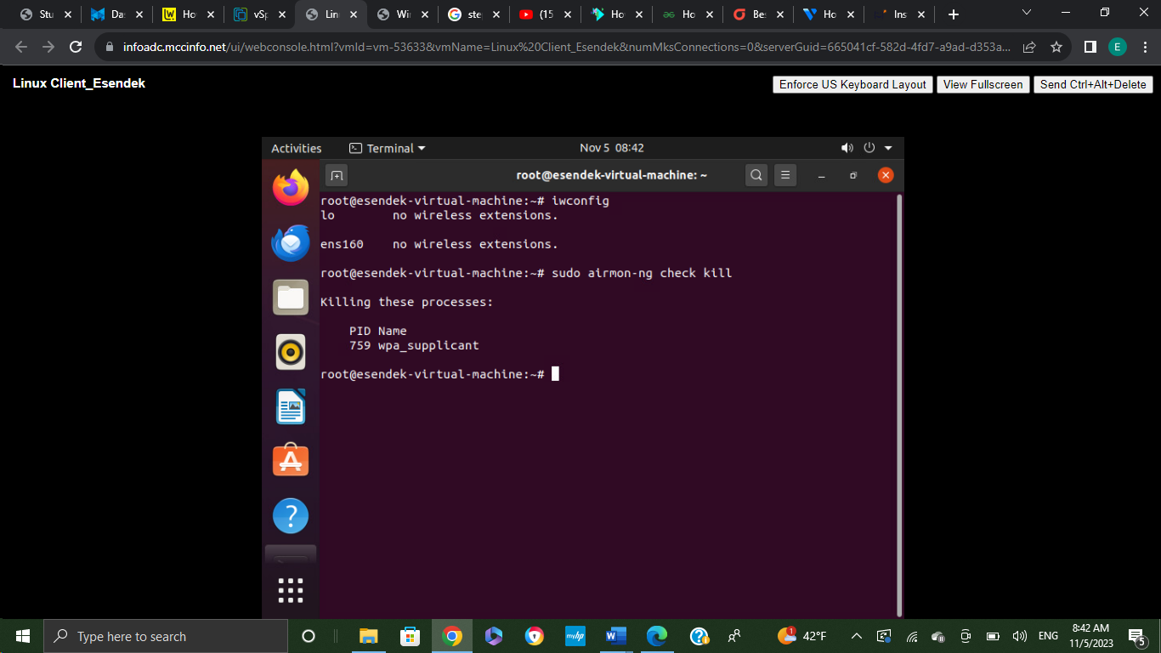

The command airodump-ng cswitch was used to see the nearby Wireless Access Points and their properties. 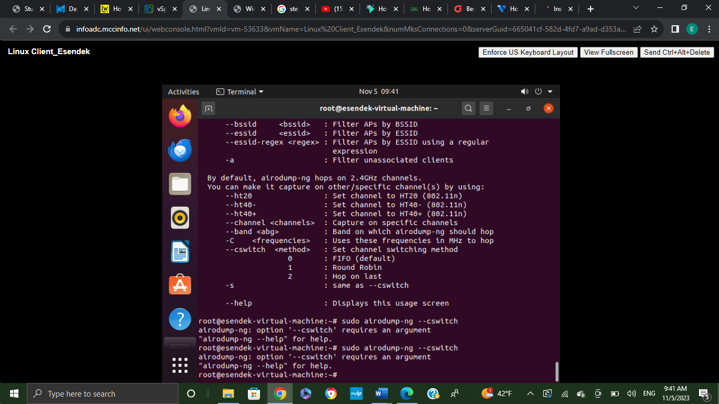

**Mitigation Measures:**

Mitigating the identified Vulnerabilities went beyond mere recommendations; tangible measures were implemented. Outdated software was promptly updated to the latest versions, utilizing tools like:

1. APT (Advanced Package Tool): Used to manage software packages on Linux systems, facilitating the updates of software to patched versions.
2. Implement OS and Software Updates: Ensure the windows server, windows client, Linux server, and Linux client is regularly updated with the latest security patches and updates.
3. Network Segmentation: Evaluate and implement network segmentation strategies to minimize the impact of potential breaches.
4. Firewall Configuration: Review and strengthen firewall rules to restrict unnecessary access.
5. User Authentication Policies: Enforce strong password policies and consider multi-factor authentication for enhanced security.

**Installation of WAZUH:** using the command curl -sO [https://packages.wazuh.com/4.6/wazuh-install.sh && sudo bash./wazuh-install.sh](https://packages.wazuh.com/4.6/wazuh-install.sh%20&&%20sudo%20bash./wazuh-install.sh)

Wazuh is an open-source platform for security monitoring and management that offers a wide range of features. It includes intrusion detection to spot potential threats and file integrity monitoring (FIM) to detect unauthorized changes to important system files. Wazuh gathers and analyzes log data from different sources, providing insights into security events and system operations. It helps identify and assess system vulnerabilities and checks configurations against best practices and compliance standards. Wazuh also assists organizations in meeting regulations like GDPR, PCI DSS, and HIPAA. As a Security Information and Event Management (SIEM) tool, it collects and analyzes data in one place, sending real-time alerts for quick incident response. Using the Elastic Stack for data storage, processing, and visualization, Wazuh is a scalable and powerful tool for improving security operations.

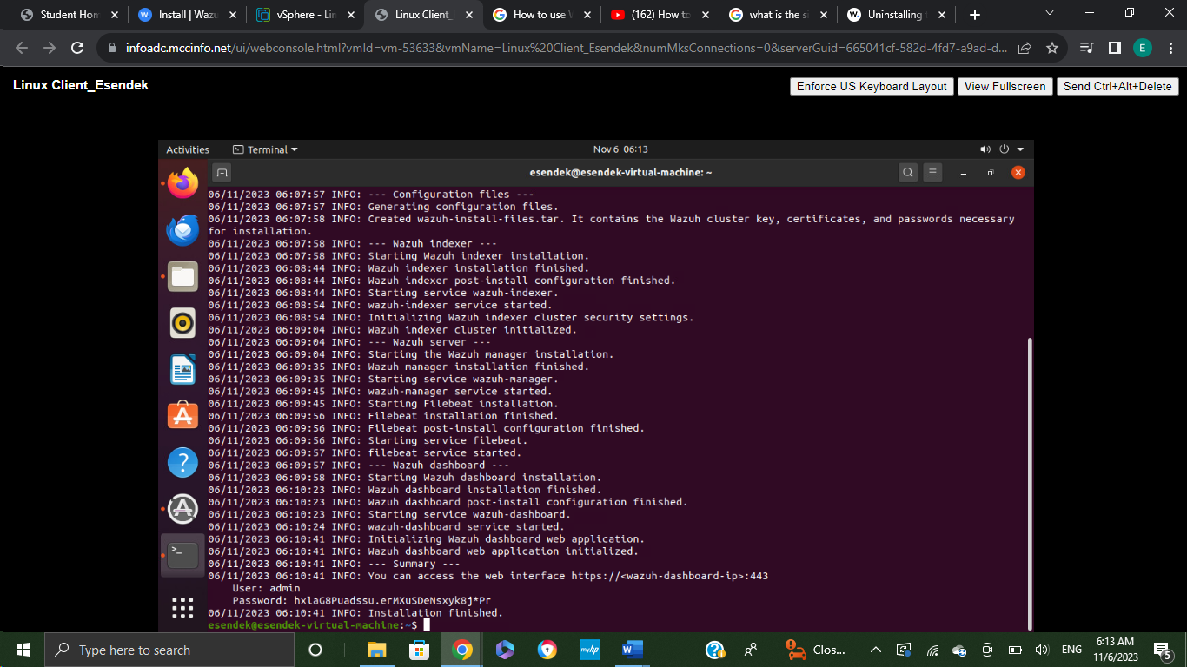

The screenshot provided below shows the commands used to connect WAZUH from windows client.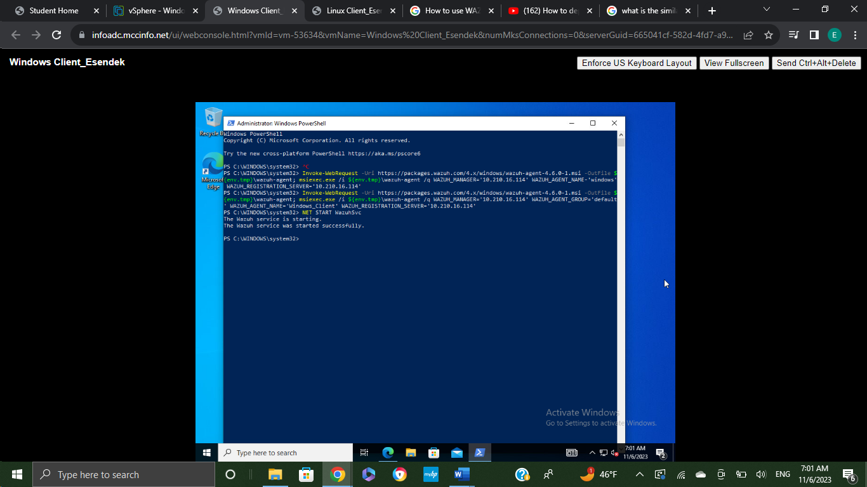

The capture below shows that Microsoft Windows 10 Enterprise is active and connected from the Linux Client machine using WAZUH. 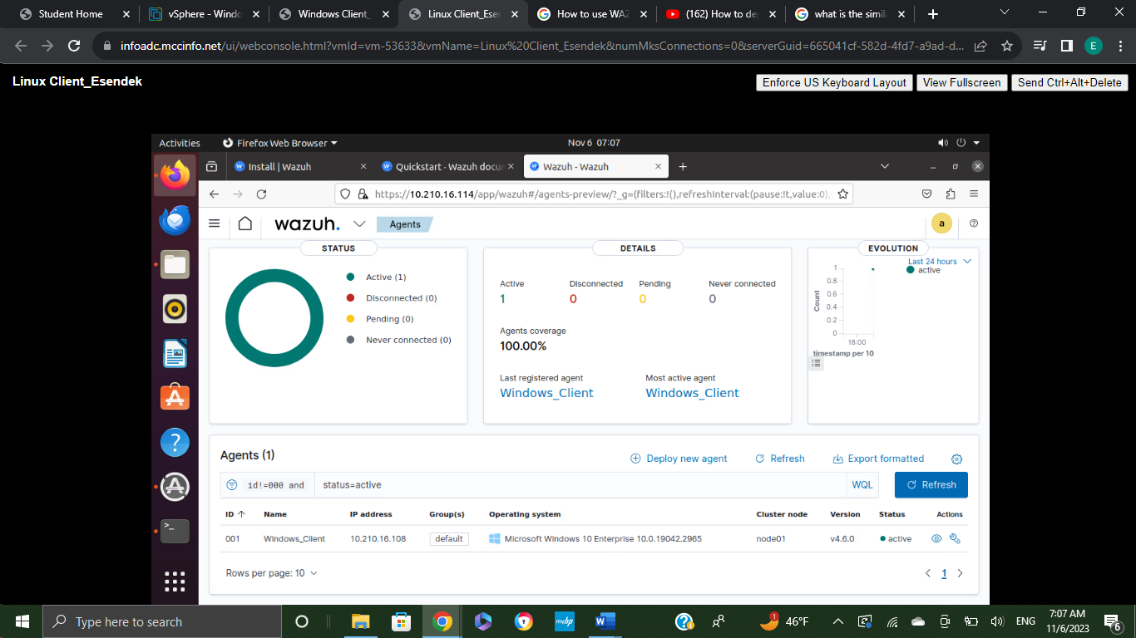

Password-related vulnerabilities were addressed through the enforcement of complex password policies, adjusting settings using the native tools provided by the respective operating systems. In simpler terms, these mitigation actions are like strengthening the doors and windows of a house. The updates and strengthened passwords act as locks and security cameras, strengthening the network against potential threats.

**Harden the Network and Systems:**

Building upon the mitigation efforts, additional steps were taken to harden the network and systems using relevant tools:

1. Firewall Configuration: Utilized the built-in Windows Firewall for Windows based systems and iptables for Linux based systems to filter incoming and outgoing traffic.
2. Intrusion Detection Systems (IDS): Deployed Snort, an open-source IDS, to detect and respond to abnormal network activities.
3. Access Controls: Utilized tools like Windows Active Directory and Linux permissions to tighten access controls, ensuring only authorized users could access sensitive information.

This comprehensive hardening process is analogous to installing a robust security system in a building. It not only secures individual entry points but also ensures the entire network is equipped to block potential security breaches.

**Vulnerability Retesting:**

Post mitigation and hardening, a critical phase involved rerunning vulnerability tests using Nmap and OpenVAS. This iterative process was instrumental in verifying the efficacy of the applied measures in addressing the initially identified vulnerabilities. Results were documented, once again ensuring that all visuals consistently incorporated the students name for clarity and accountability.

References

Azad, B. U. (n.d.). *Install AirCrack-Ng on Ubuntu*. <https://linuxhint.com/install_aircrack-ng_ubuntu/>

Kaplarevic, V. (2022, December 14). *How to install NMAP on Ubuntu*. Knowledge Base by phoenixNAP. <https://phoenixnap.com/kb/how-to-install-nmap-ubuntu>

Morgan, M., & Morgan, M. (2021, April 7). *How to install and Configure Nikto on Ubuntu 20.04*. ElderNode Blog. <https://blog.eldernode.com/install-and-configure-nikto-on-ubuntu/>

Orgera, S. (2020, July 8). *How to use Wireshark: A complete tutorial*. Lifewire. <https://www.lifewire.com/wireshark-tutorial-4143298>

Wazuh. (2024, January 17). *Overview | Wazuh*. Wazuh. <https://wazuh.com/platform/overview/>